Location Selfies (13 Locations):

1. Viterbi School of Engineering 2. Marshal School of Business

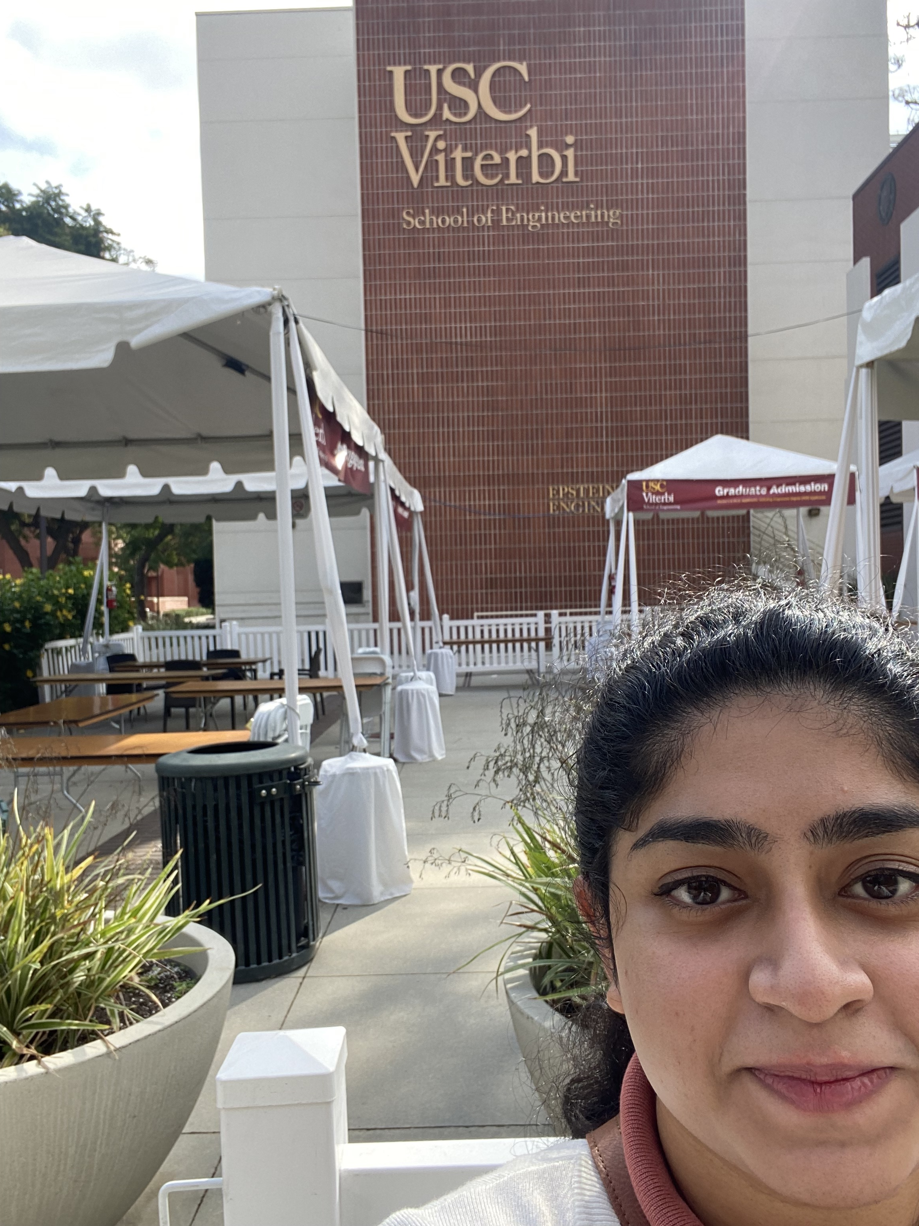 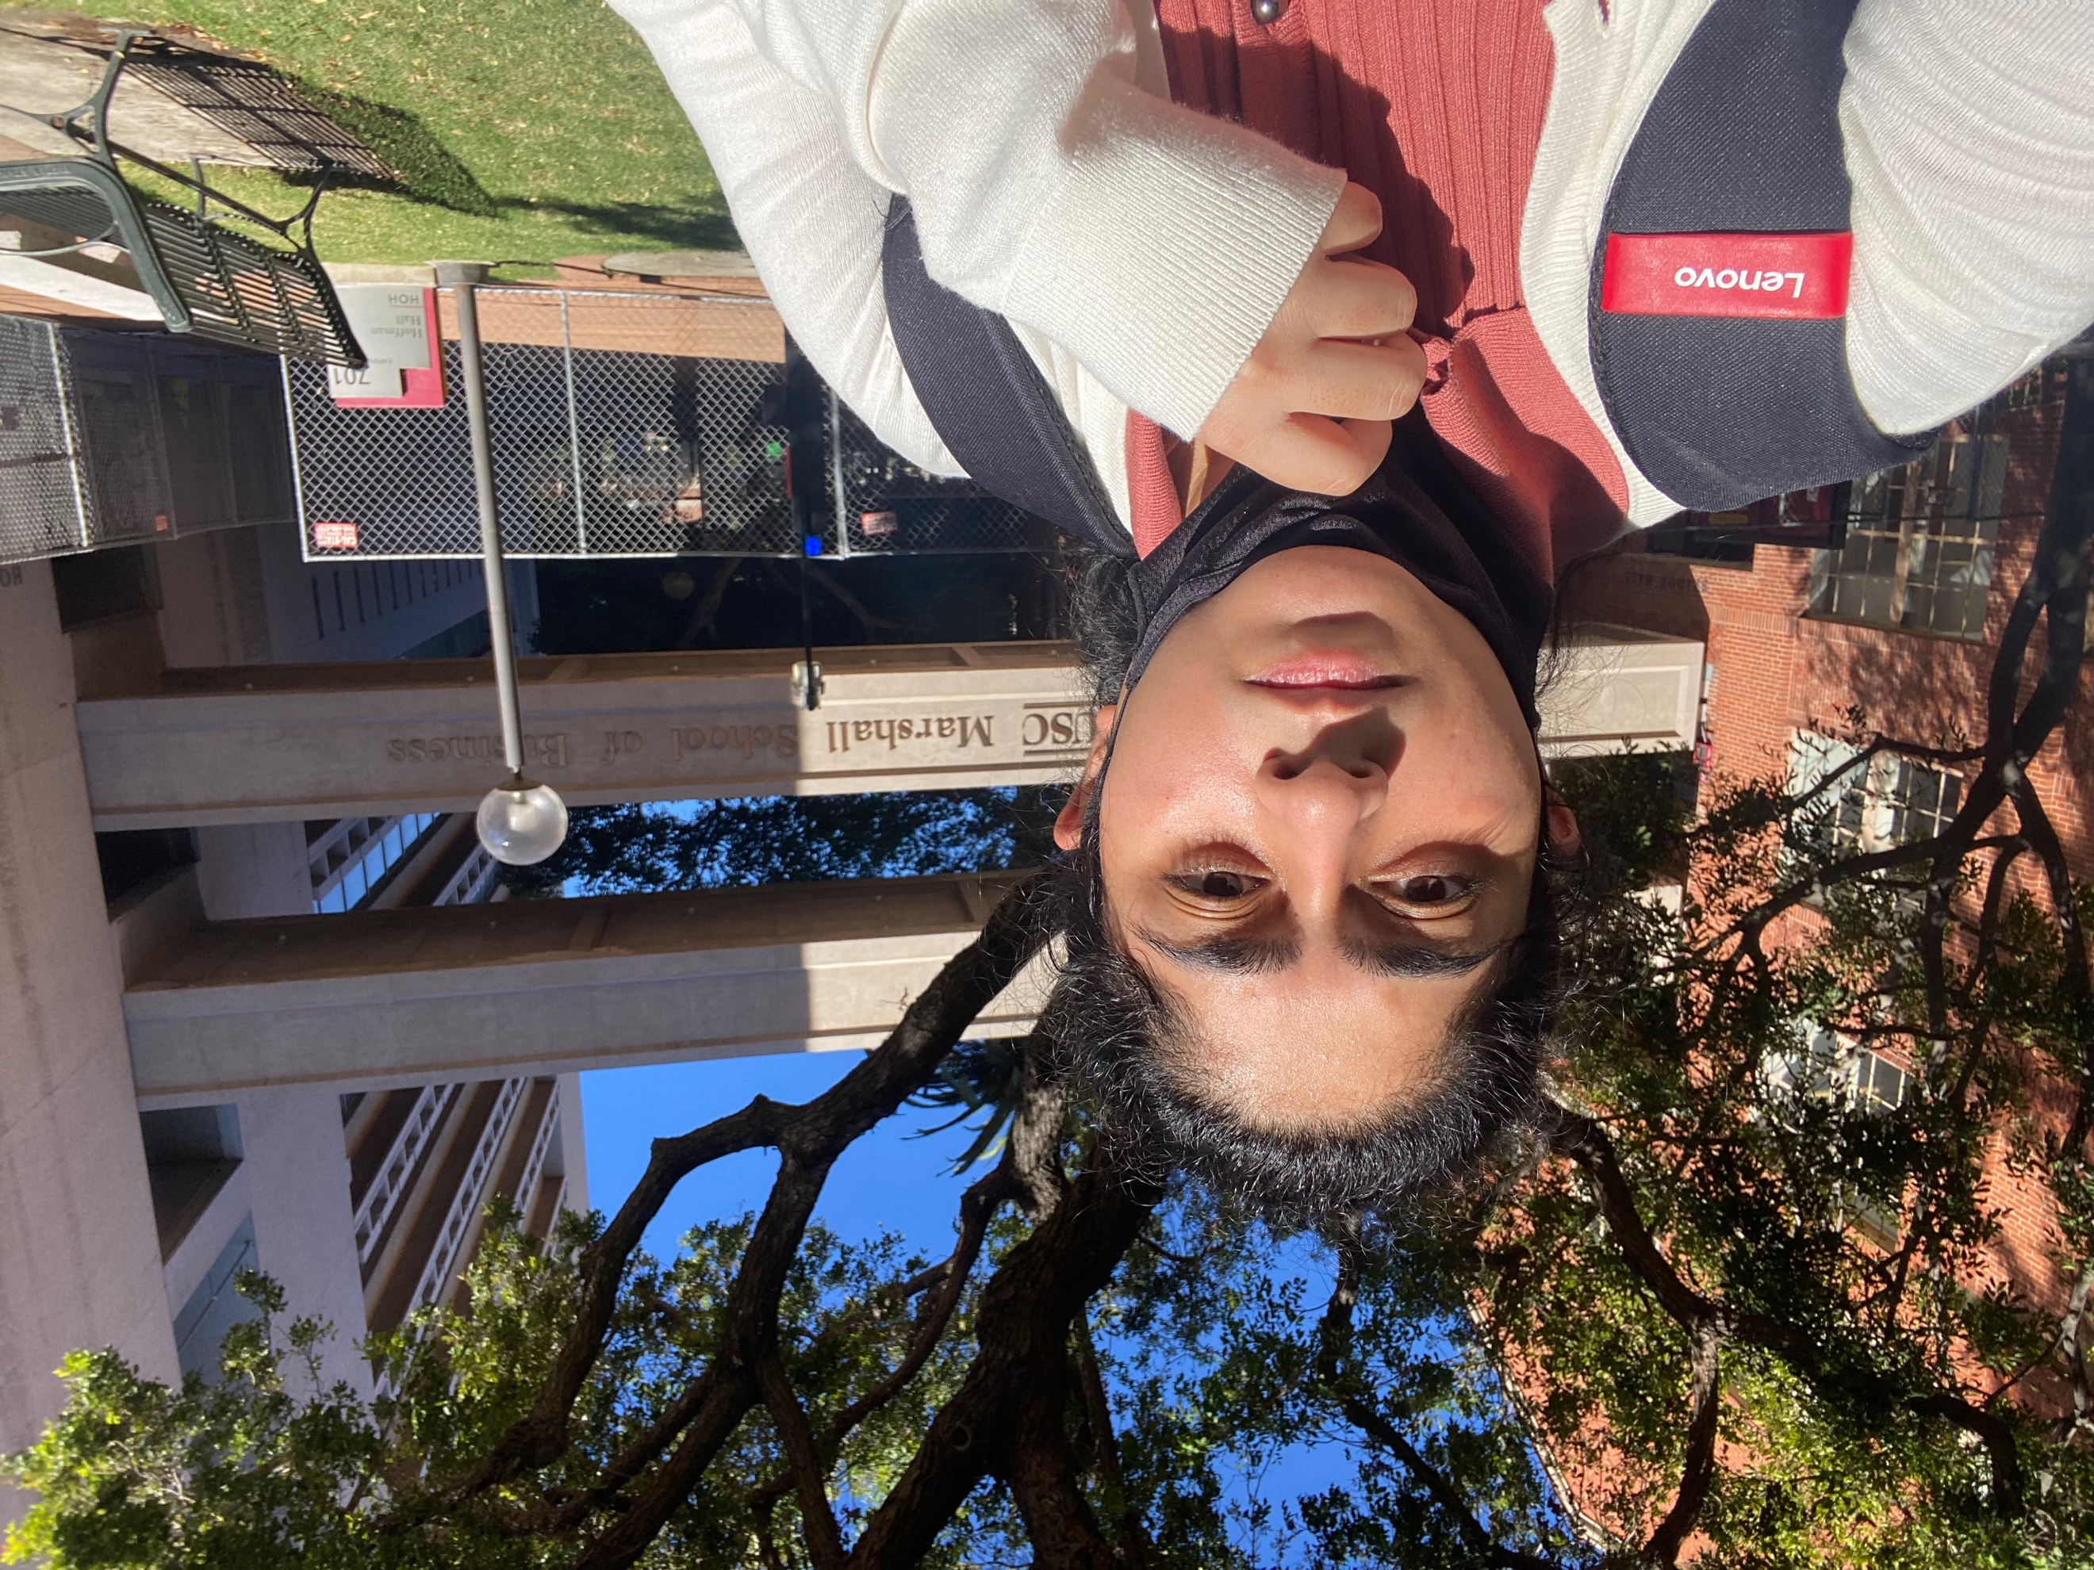

1. Engemann Student Health Center 4. School of Cinematic Arts

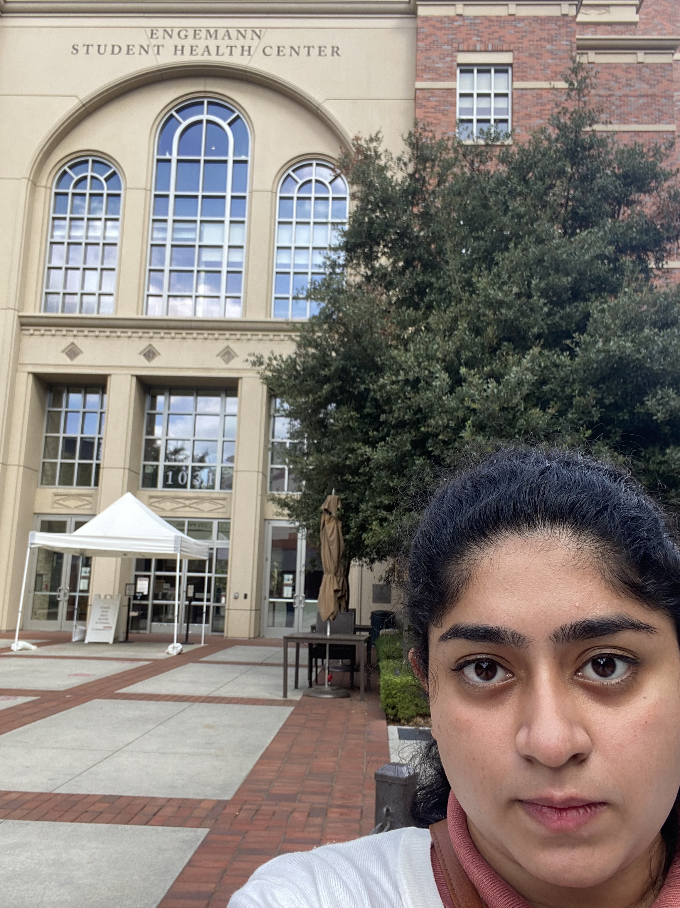 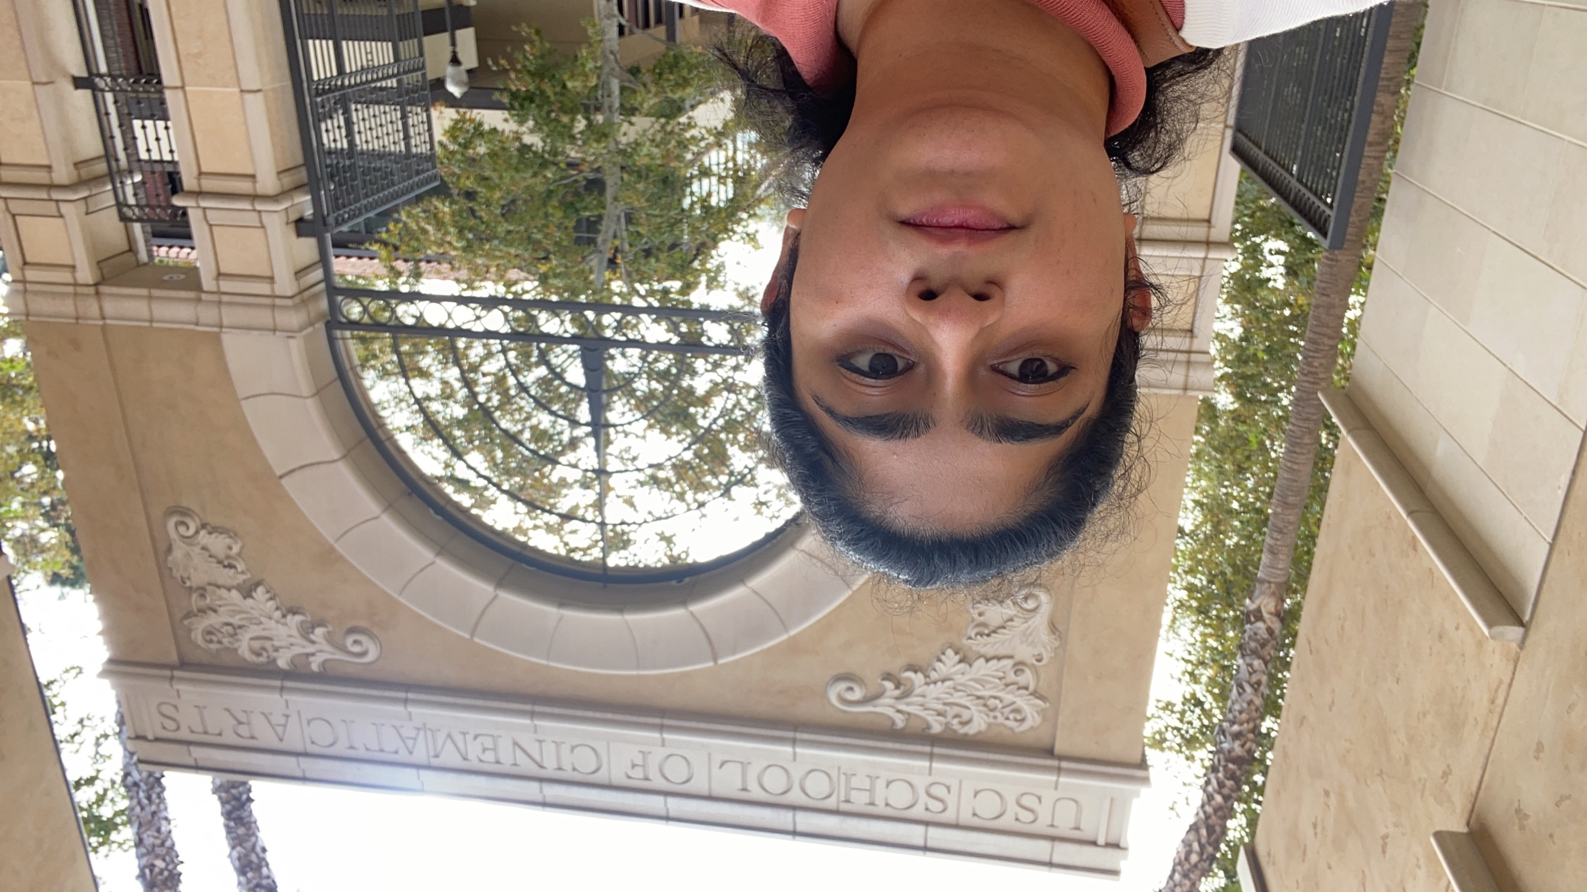

1. Annenberg School for Communication 6. Ethen Percy Andrus Gerontology Center

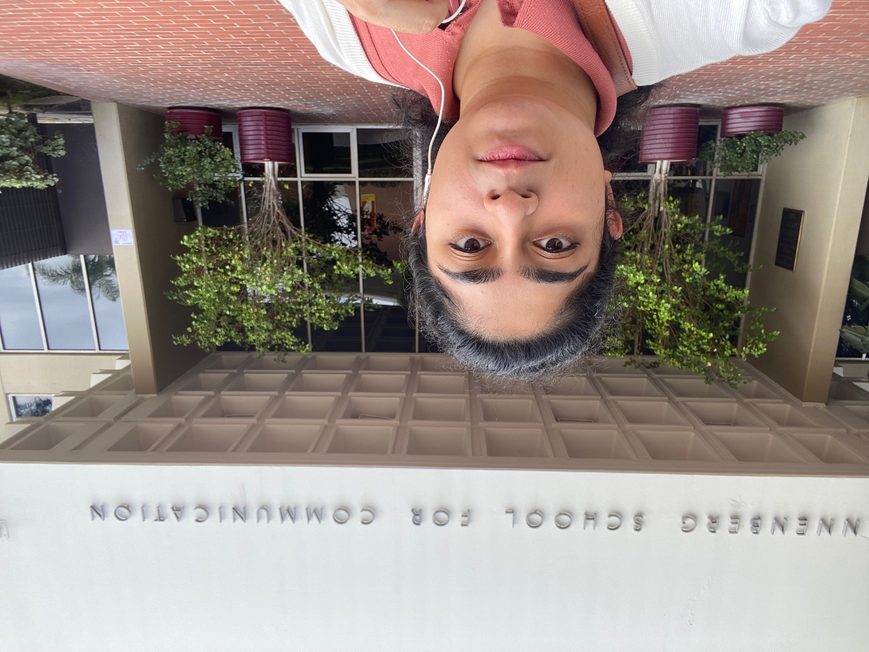 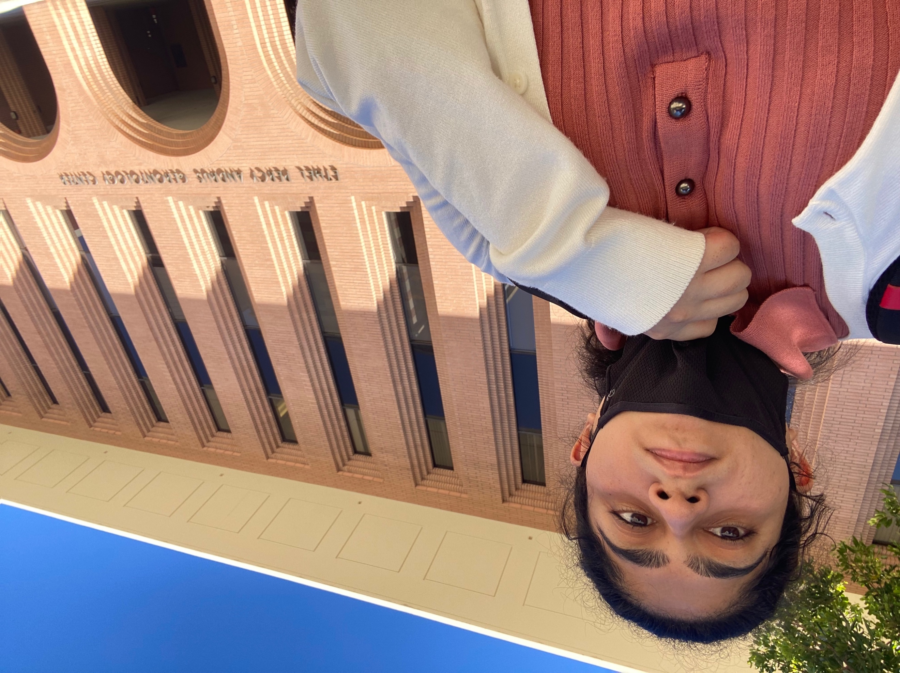

7. Pardee Tower 8. Kaprielian Hall

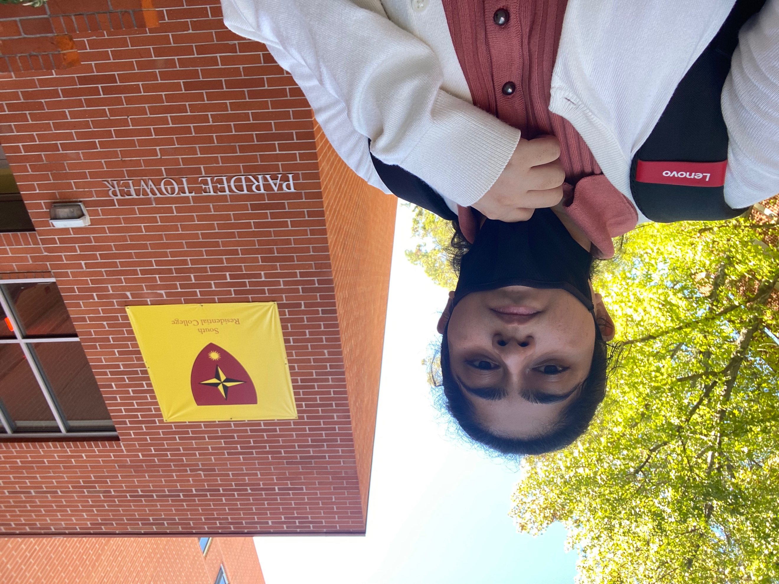 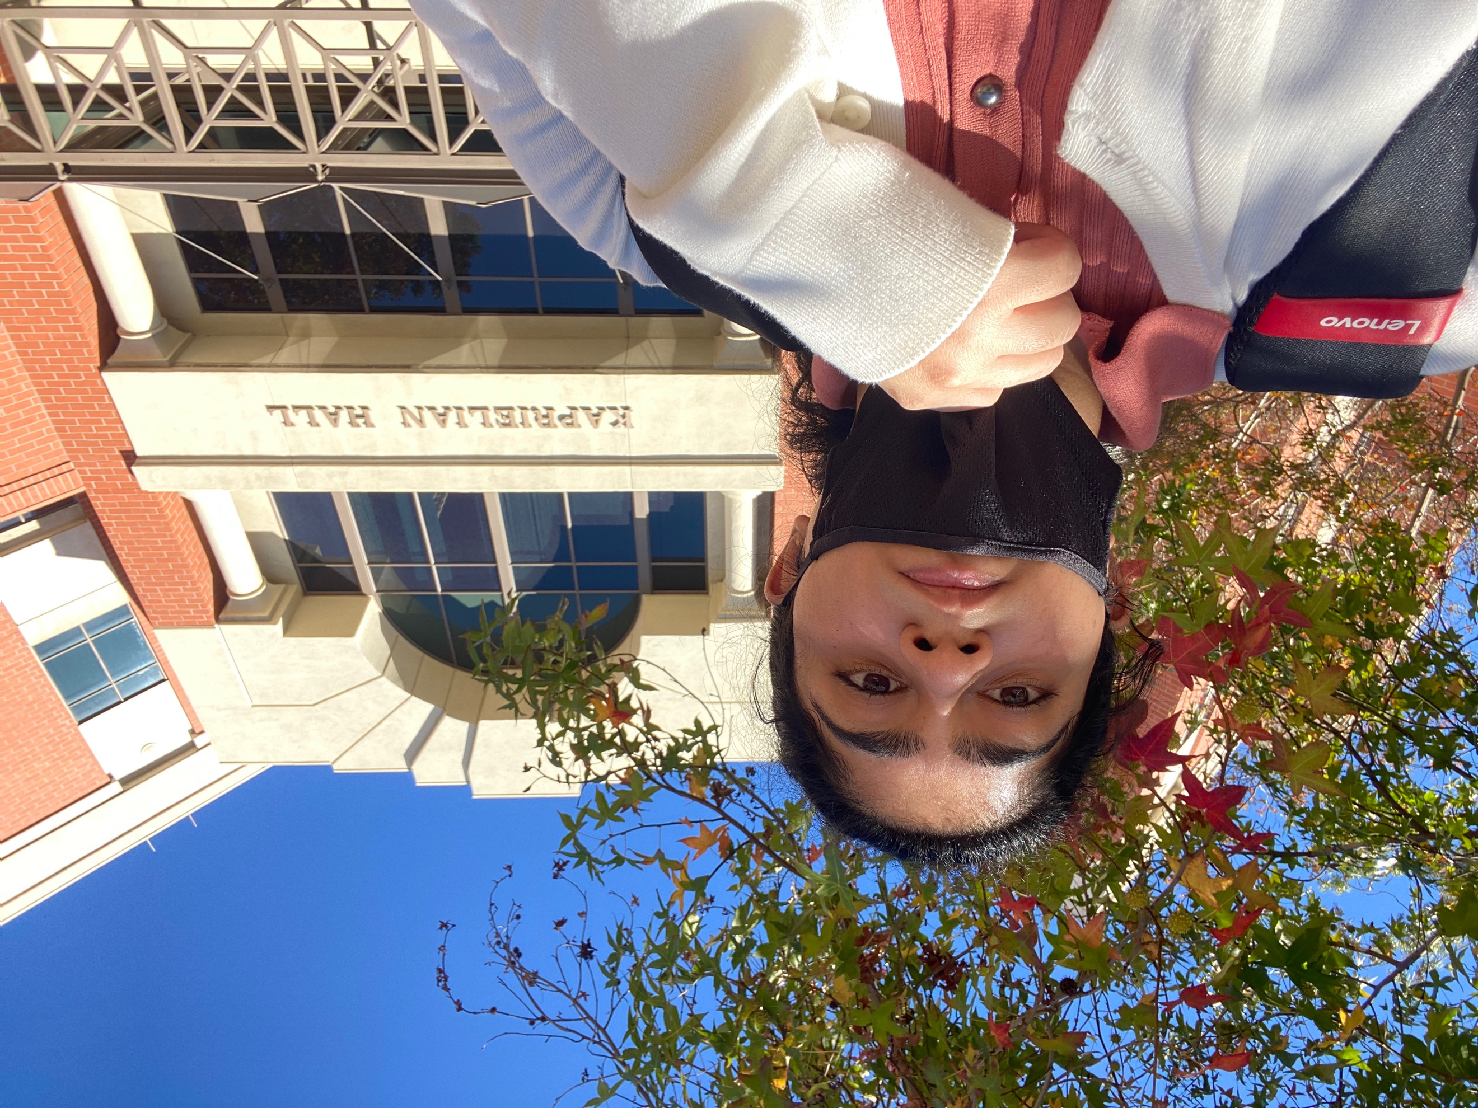

9. Mudd Hall 10. Doheny Library

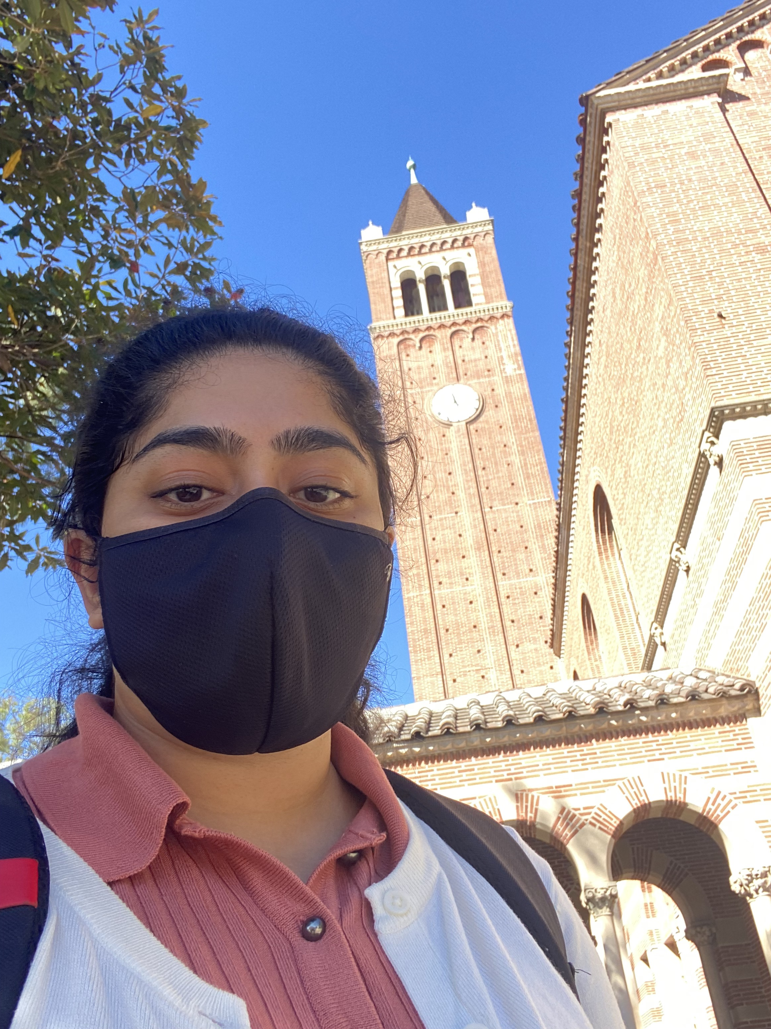 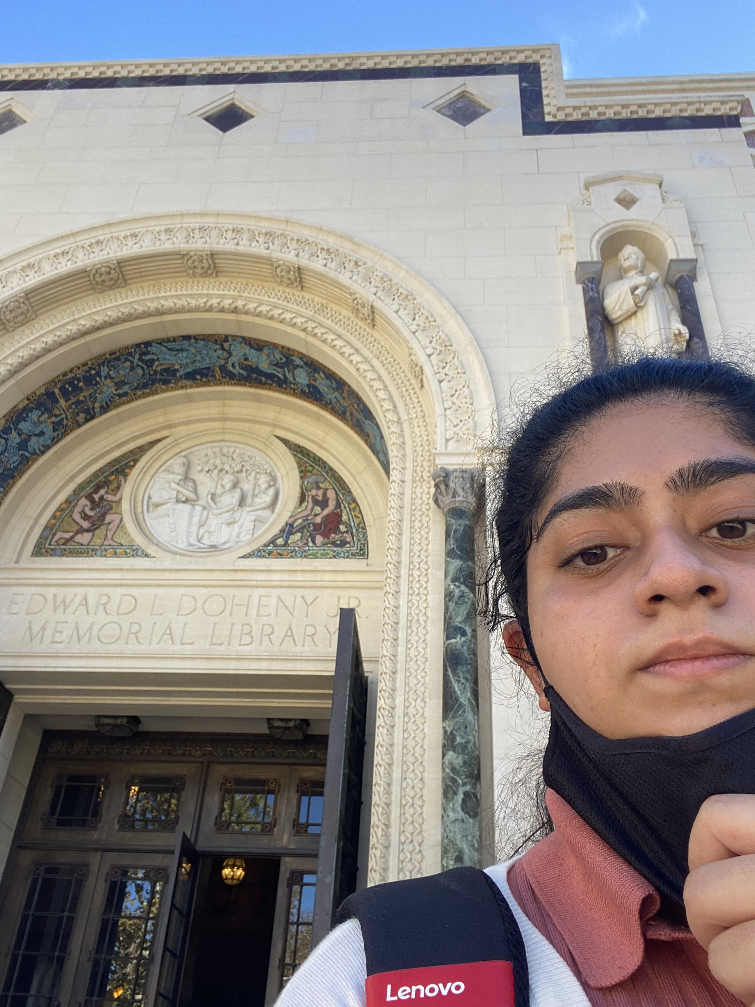

11. SAL 12. Bloom Hall of Fame Walk

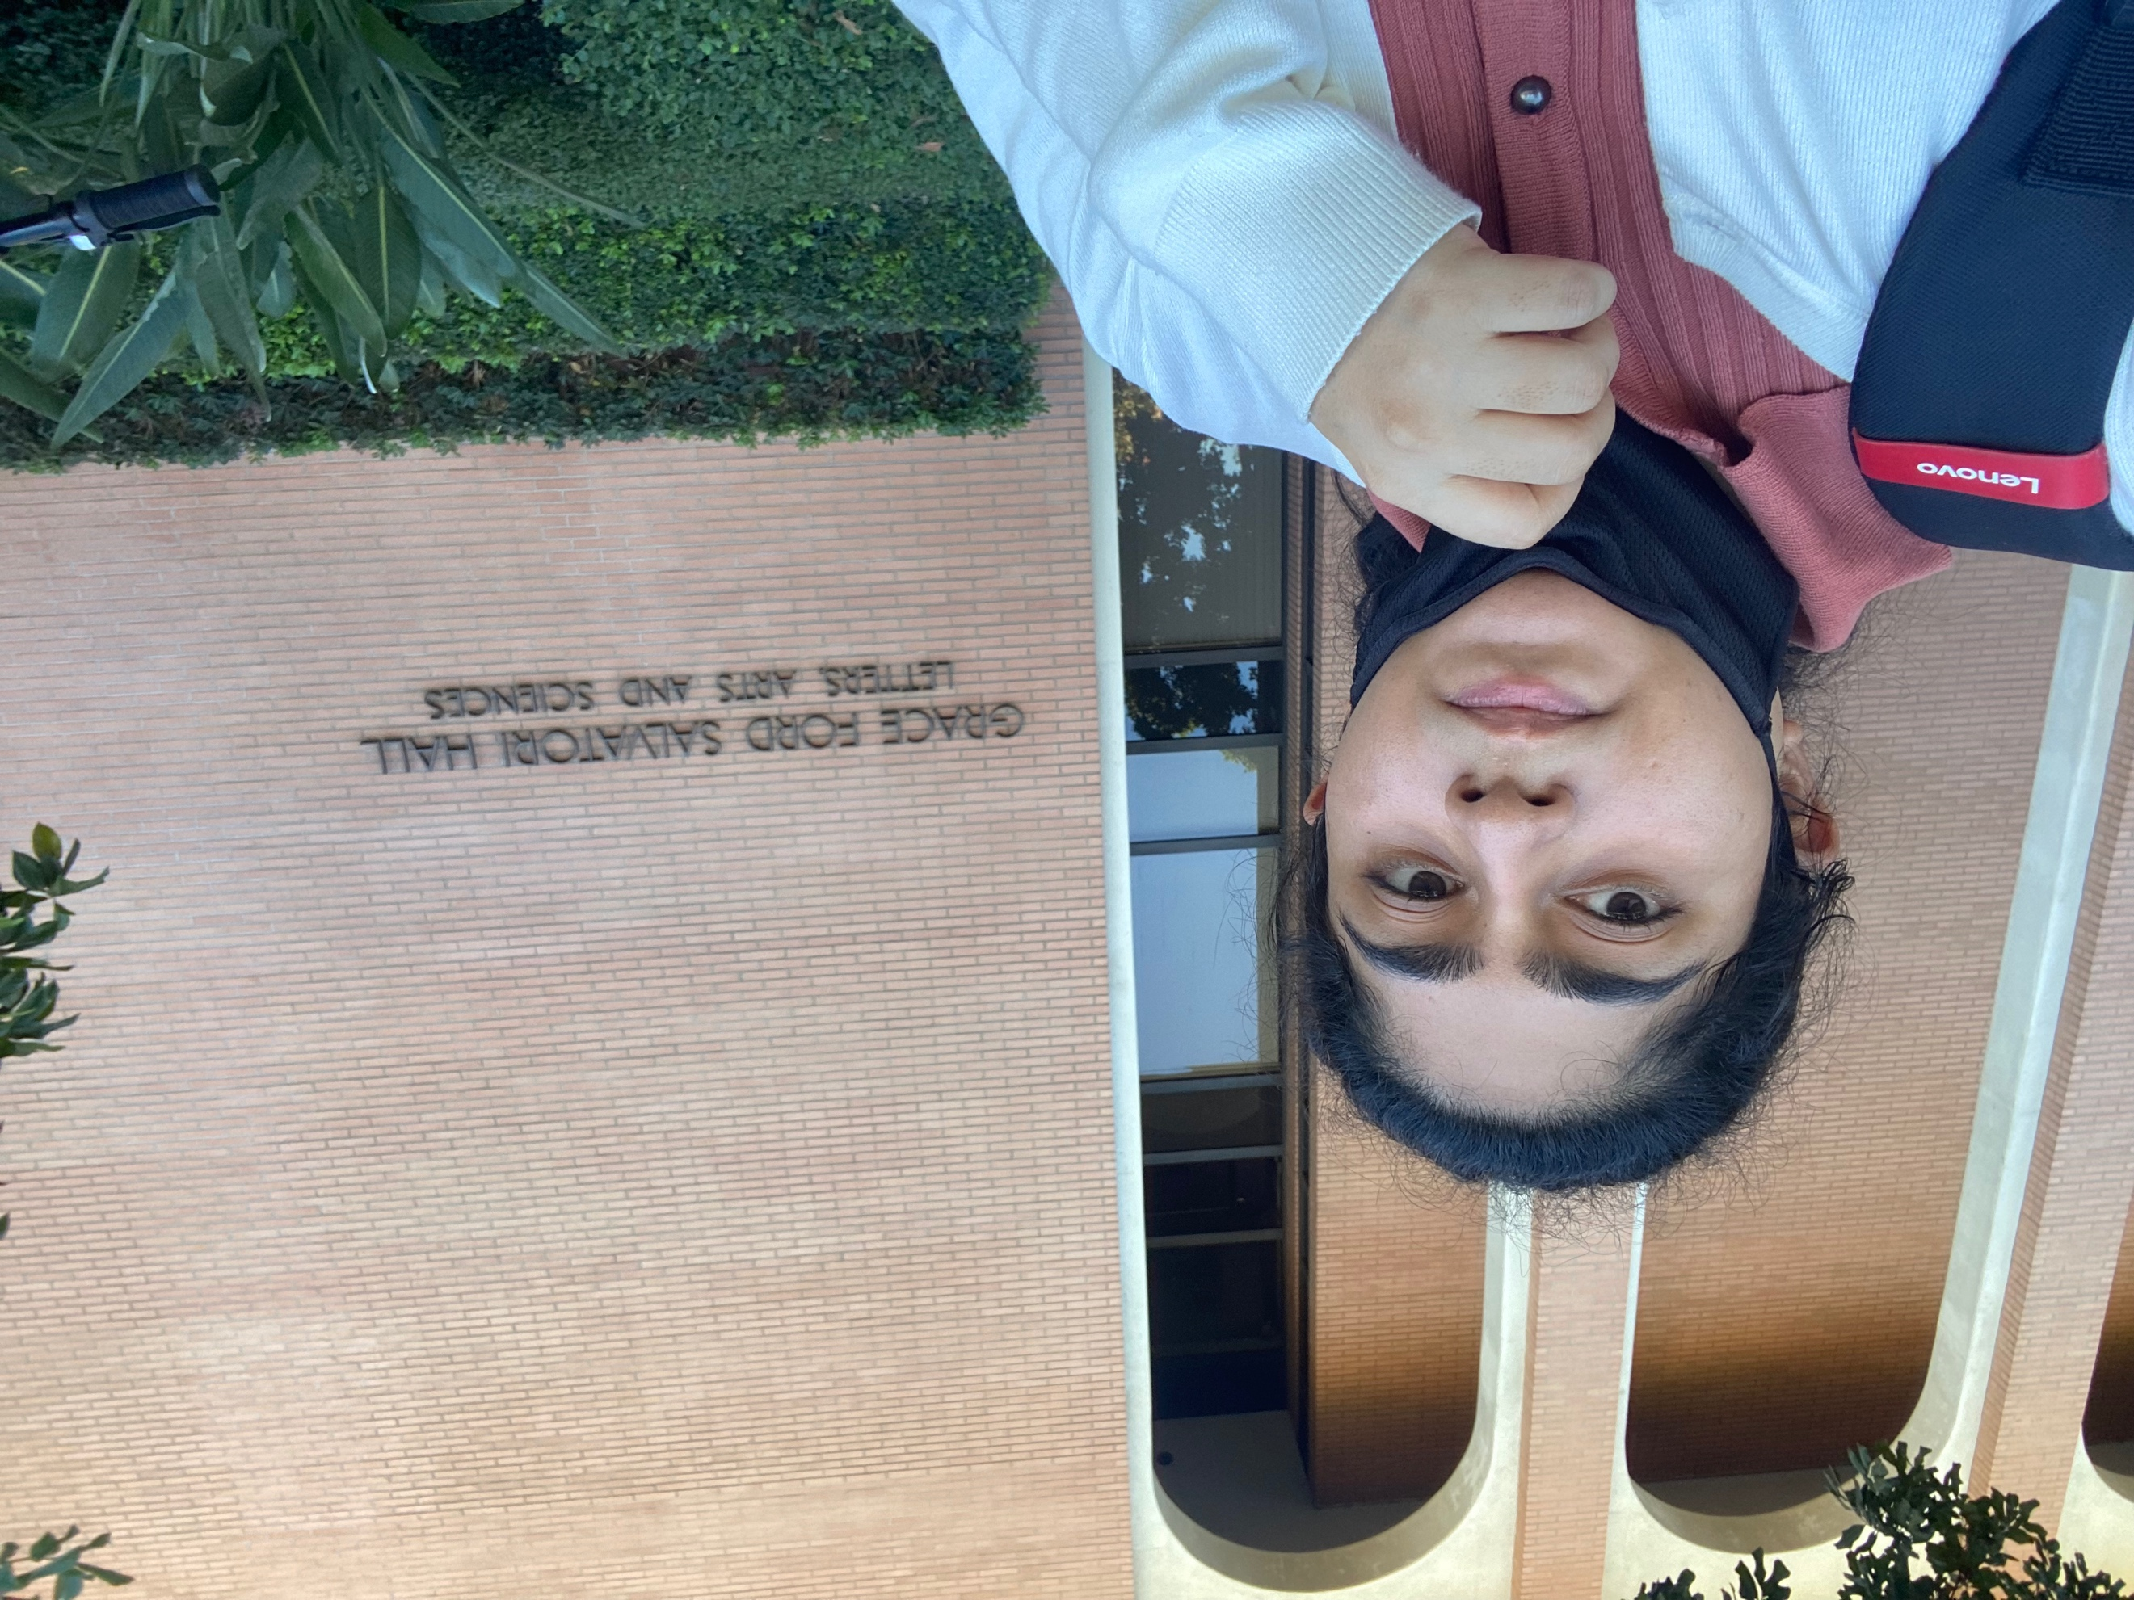 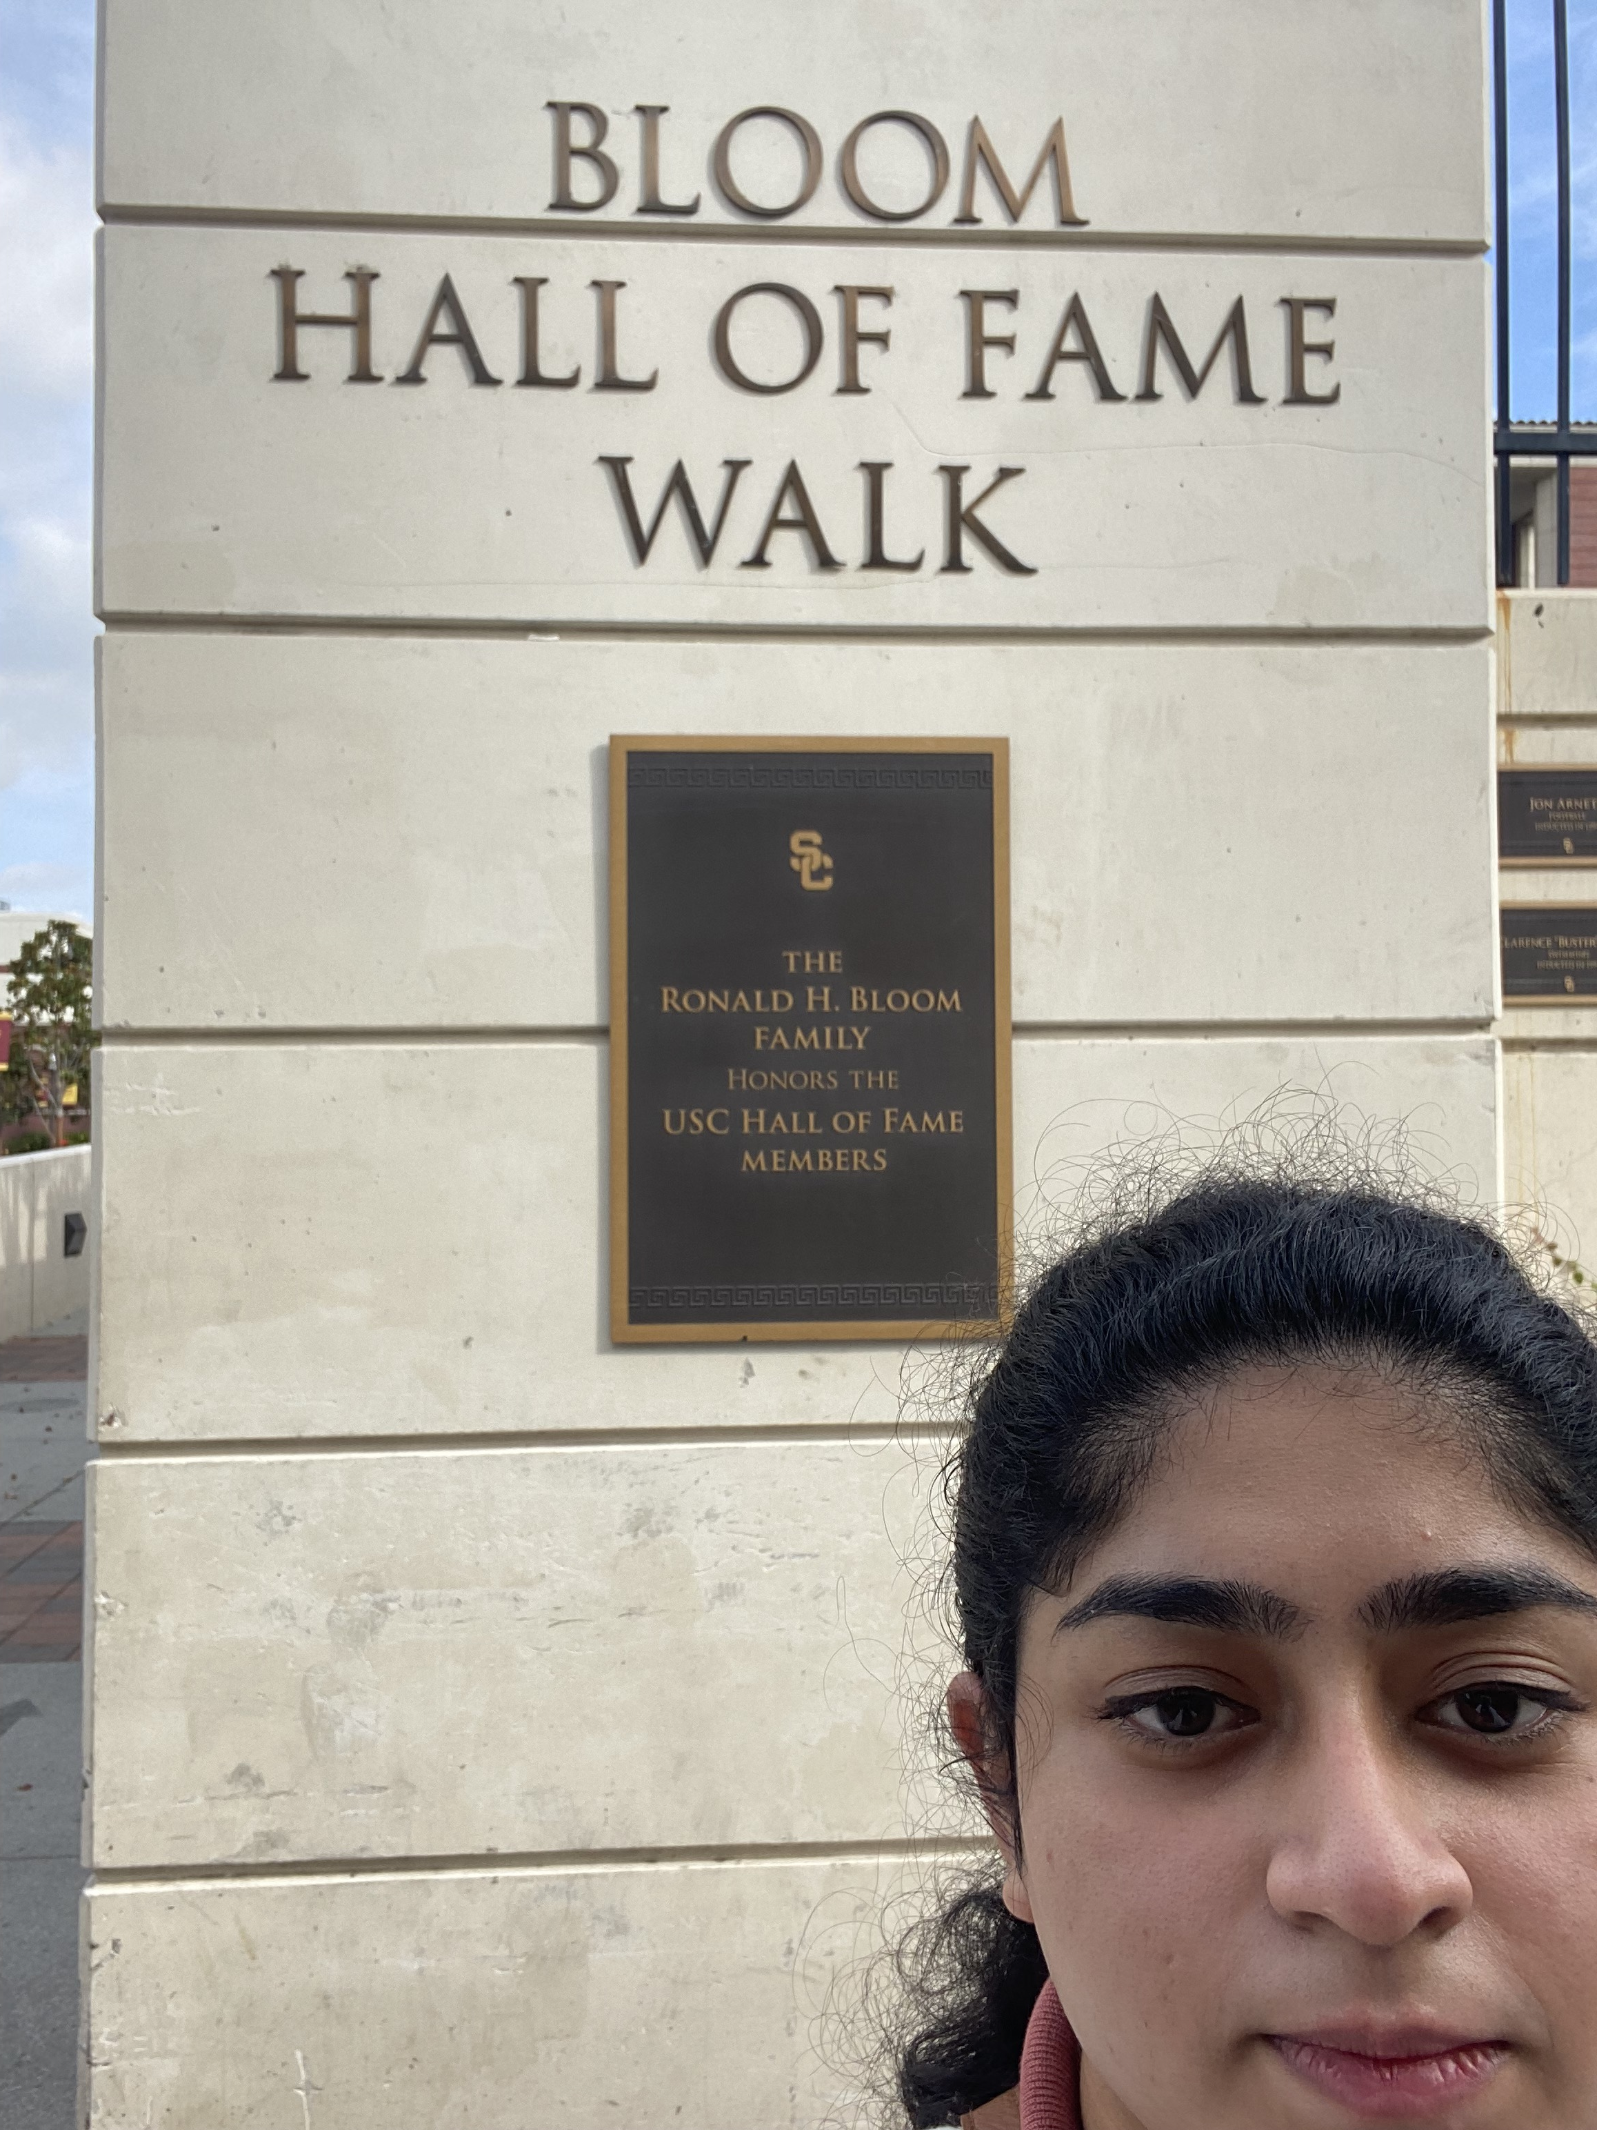

13. Menlo Ave (Apartment)

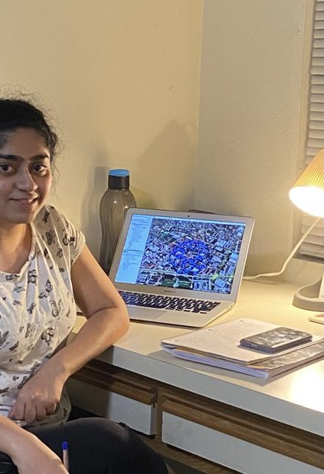

Locations with co-ordinates:

1. Viterbi School of Engineering, (34.02079561940858, -118.288999246309)

2. Marshal School of Business, (34.018611961910864, -118.2855781597874)

3. Engemann Student Health Center, (34.02470454132185, -118.288560605085)

4. School of Cinematic Arts, (34.02305997944613, -118.286258249574)

5. Annenberg School for Communication, (34.02217844004107, -118.2866553299484)

6. Gerontology Center, (34.02008723287236, -118.2903170891546)

7. Pardee Tower, (34.01993996106996, -118.282202018845)

8. Kaprielian Hall, (34.02176766025603, -118.290729456429)

9. Mudd Hall, (34.018626390795625, -118.28654482089)

10. Doheny Library, (34.020491549170394, -118.284333747541)

11. Grace Ford Salvatori Hall, (34.021722759583525, -118.288204729877)

12. Bloom Hall of Fame Walk, (34.02274365712791, -118.2884292156644)

13. Room (Menlo Ave) , (34.02961699396593, -118.2900615601698)